**OUTREACH SCHOOLS EXAMINATION BOARD**

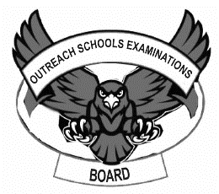 **BEGINNING OF TERM III EXAMINATION 2024**

**PRIMARY THREE**

**LITERACY II**

**A**

**B**

**For Examiner’s**

**use only**

**TOTAL**

***Time Allowed: 2hours 15 minutes***

**Name: ______________________________________________**

**School: _____________________________________________**

**Class: _______________________________________________**

1. **Fill in the missing sounds.**

b ……. …..k m …… ……n h …… ……l m …… ……t

1. **Write these correctly.**

sub …………………………………. nva ………..…………………….

atbo ……………………………….. cyclebi ........................................

1. **Draw these plants.**

|  |  |  |
| --- | --- | --- |
| sisal | cactus | banana plant |
|  |  |  |

1. **Make words with the given sounds below.**

b ………………………………….

l ………………………………….

m ake …………………………………..

sh ……………………………………

f …………………………………..

1. **Read the story to the teacher and answer the questions.**

**LIVING THINGS**

Living things are things that have life. We have many living things in our sub-county. For example plants, animals, insects, birds and others. We get many things from living things. For example money, meat from domestic animals and birds, medicine from plants and others.

Living things are important to us.

**Questions**

1. What is the story about?

……………………………………………………………………………….

1. Mention three examples of living things in the story.
2. ………………………………………………………………………..
3. ………………………………………………………………………..
4. ……………………………………………………………………….
5. Write three things people get from living things.
6. ………………………………………………………………………..
7. ………………………………………………………………………..
8. ………………………………………………………………………..
9. Write the title of the story.

……………………………………………………………………………….

1. Draw the examples of food we get from plants.

|  |  |  |
| --- | --- | --- |
| cassava | potatoes | maize |
|  |  |  |

1. **Rearrange the sentences to make a correct story.**
2. He smoked the pot and put drinking water.
3. He made a pot out of clay soil.
4. He collected clay soil.
5. Peter wanted to drink pot water.
6. He went to the swamp.

**Correct Story**

1. ……………………………………………………………………………
2. …………………………………………………………………………..
3. …………………………………………………………………………..
4. …………………………………………………………………………..
5. …………………………………………………………………………….
6. **Complete the sentence with the correct word from the brackets.**

a) My father has one …………………………... (sun, son)

b) We had tea and ……………………………. (bans, burns)

c) I .................................. my teacher every morning. (meet, meat)

d) The visitor was given a ......................... (sit, seat)

1. **Make sentences using these words.**
2. animal: ……………………………………………………………………..
3. forest: ……………………………………………………………………….
4. diseases: ……………………………………………………………………
5. shoes: ………………………………………………………………………
6. **Use the first syllable to form a new word.**

a) **ma**ngo .................................................

b) **ke**nnel.................................................

1. **Copy and write.**

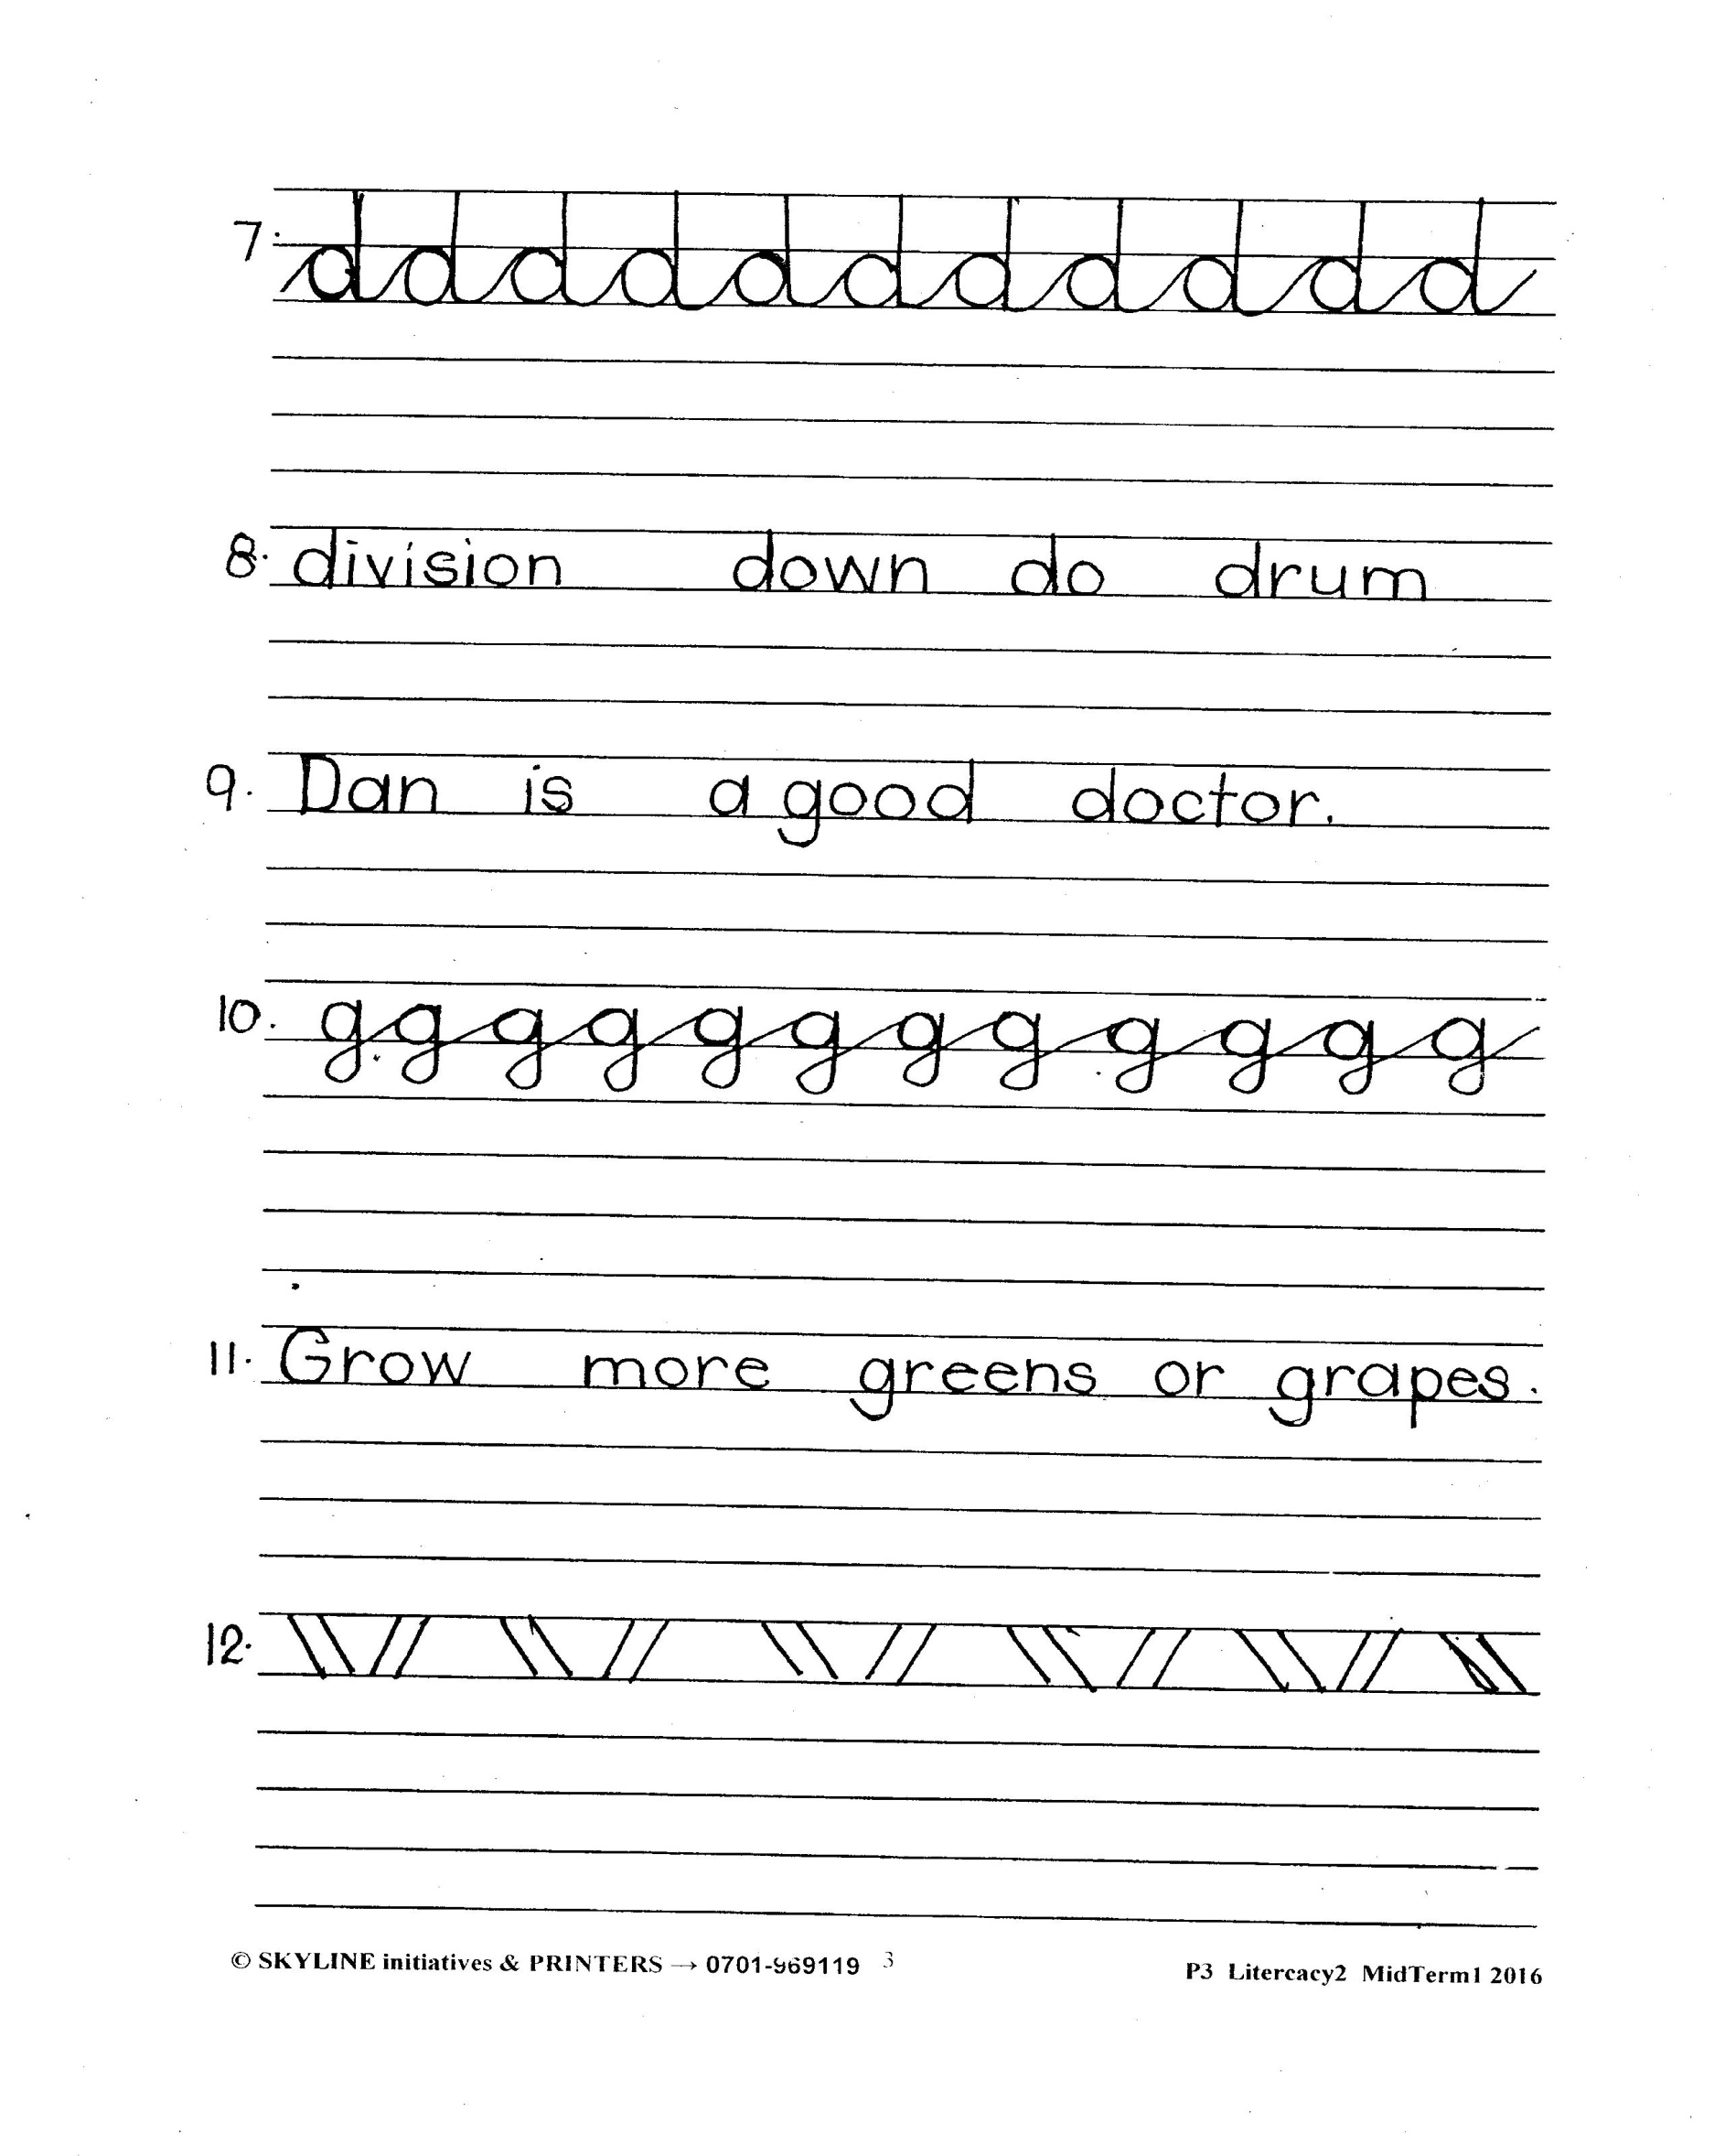

**END**